*Green Society Public School*

**Ra.Na.Pa-7, Sauraha Chitwan**

**First Terminal Examination- 2082**

**Subject: Art F.M.: 25**

**Class: Five**

**Name: Roll.no**.

**Q.N.1) Colour the given shapes. [10]**

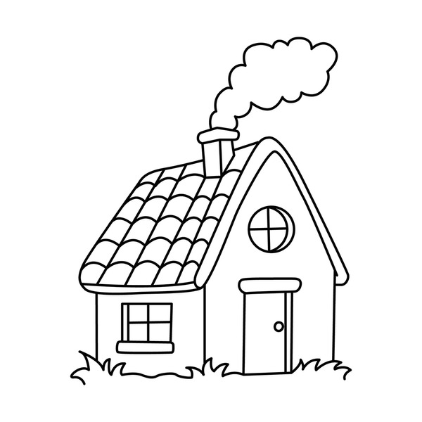

Q.N.2) Draw a picture of an scenery and colour it. [15]